DRAFT Breathing Apparatus Daily Check – Dräger PSS 100/7000 (v0.3)

NOTE – if you are reading a paper copy of this note it may not be the most up-to-date version. For the latest version view the information on PROCLUS.

Frequency:

Before use:

- At change of shift or change of nominated wearer. NOTE - it is the individual BA wearer’s responsibility to check their own set.
- Prior to each wear of the set: “prior to each wear” is defined as no more than the duration of a single, continuous shift and; where the wearer and appointed HART Team Leader are satisfied that the set could not have been moved or changed.
Minimum Competency Level:

- A competent (qualified) BA wearer
- Trainees under the supervision of a Breathing Apparatus Instructor
- Dräger-approved technicians
Personal Hygiene:

- Prior to testing or wearing; all staff must ensure they are clean-shaven around the face seal to achieve an effective fit when using the BA facemask.
- On completion of testing: ensure facemask is appropriately cleaned, using approved cleaning materials as-per the relevant Equipment Data Sheet.
Fault Reporting:

- Any BA set found to be faulty during normal testing must be removed from service immediately. The BA set logbook must be completed to reflect this, including a description of the problem in the fault-reporting section at the back of the logbook. The logbook must then be placed back in its pouch, with the “Do Not Use” sign on the back cover facing outwards to prevent others inadvertently using the set.
- In all incidences where a BA set fails the HP leak test more than once; the set, facemask, LDV and cylinder must be left in-situ and defected. All parts of the set, cylinder, etc., should remain connected as they were when the HP leak test was carried out, subject to further investigation by a suitably qualified person. Ensure the set is fully drained of air.
- It must then be reported to the duty Team Leader, as well as your local BA Technician/Champion for them to either repair, or to arrange repair/replacement of the affected items as per your Trust’s Service Contract.
Recording Instructions:

- All records of tests must be recorded in the BA log book immediately on completion of the test, and in BLACK INK. These records must be complete, legible, accurate, and accessible. On completion of a Daily Test, a D is to be recorded in the log book.
- Cylinder pressures – when entered – must be rounded-down to the nearest 10bar (e.g., if the gauge reads 309bar; round down to 300bar)

Stowage:
- Where the BA set is stowed on a vehicle, check that it is correctly secured to its bracket, and that any fastening and release device is working correctly. Check that the BA set is on-charge in the vehicle, and that the vehicle itself is also on-charge.

Personal-issue Facemasks and Optical Inserts:

- Personal-issue facemasks and optical inserts must be fitted prior to carrying out a Daily Check.
- Personnel who have been issued with either of the above must ensure that they continue to monitor their effectiveness, and in the event of the shape of their face changing, or eyesight deteriorating must bring this to the attention of their Line Manager.
- Personnel must remove personal-issue facemasks and optical inserts post-wear (unless intending to wear again) or at change of shift.

Visual Inspection:

BA Set
- Check ID numbers match on logbook, tally and, where applicable: Bodyguard radio pack.
- Check ID number on LDV matches number on front of logbook.
- Check that all hose clips are present and secure
- Check all webbing and stitching for signs of wear/damage/degradation. Ensure straps are in the right orientation and are not twisted.
- Fully tighten all straps, check security of adjusting devices, and then extend all straps fully again.
- Check all securing clips/buckles for signs of wear or damage. Connect and then disconnect all buckles to ensure they operate correctly.
- Adjust back-plate to correct height for user.
- Inspect all hoses and ensure they are all securely fitted to BA set.
- Ensure male and female quick-release couplings for supplemental air are fitted, that they are free from debris, and that their protective caps are present and secure.
- Extend personal line fully – checking correct function, and examine the line for signs of wear/damage.
- Ensure the personal line housing unit is secured to the waist belt of the set.
- Check condition of the Bodyguard unit, screen and protective cover.
- If using a PSS100: check for debris in the mechanical low pressure warning whistle (Mechanical Whistle) located in the Bodyguard.
- If using a PSS700: check for debris in the mechanical low pressure warning whistle (LPWW) located above the first stage pressure reducer (see Fig. 1)
- Where fitted to the set: check the operation of any accessories such as torch and cable cutters.
- Check for presence of rubber buffer at base of set (see Fig. 2)
- Check for presence and condition of anti-tamper cap on first stage reducer (see Fig. 2)
- Where fitted: ensure anti-vibration clip is secured correctly.
- Ensure all aspects of the set are clean and operationally-ready. Clean set and cylinder cover if required.

(Fig. 1) (Fig. 2)
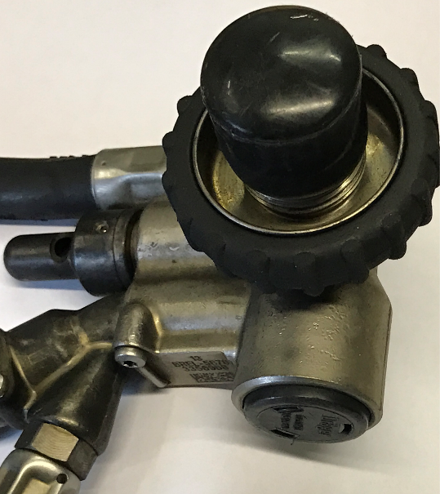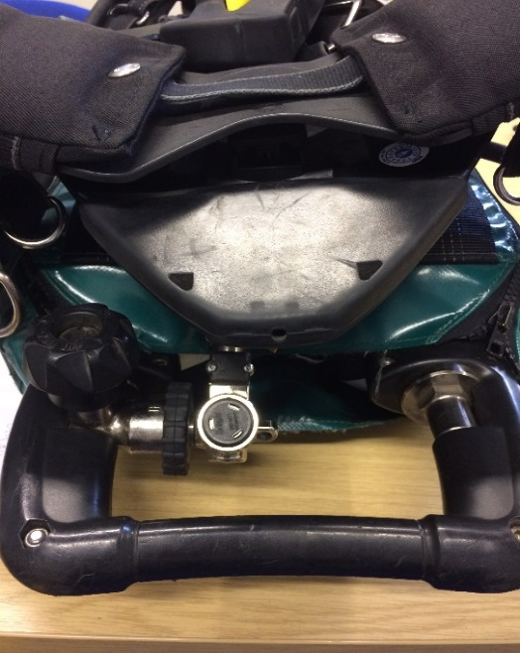
Rubber Buffer
Anti-Tamper Cap
LPWW (PSS7000)

Facemask

- Ensure facemask, inner mask, and head harness are the same size as those you are currently Portacounted for.
- Check condition of visor for damage or severe scratching/impairment
- Check exhalation valve cover intact
- Check inner mask including exhalation valve for debris
- Check for presence and condition of nose-cup valve disks
- Check condition of double reflex face-seal.
- Check condition and operation of head harness, neck loop and retaining stud. Fully tighten, and then loosen all straps.
- Where fitted: check condition and operation of BA communications equipment.
- Disconnect LDV from facemask
- Ensure LDV is free from debris, and check condition of rubber shroud and LDV O-Ring: ensure both are present and secure.

BA Cylinder

- Check cylinder connection is hand-tight.
- Where fitted – ensure anti-entanglement straps are correctly secured. Check straps for signs of wear/degradation.

Dräger Bodyguard II Key Components
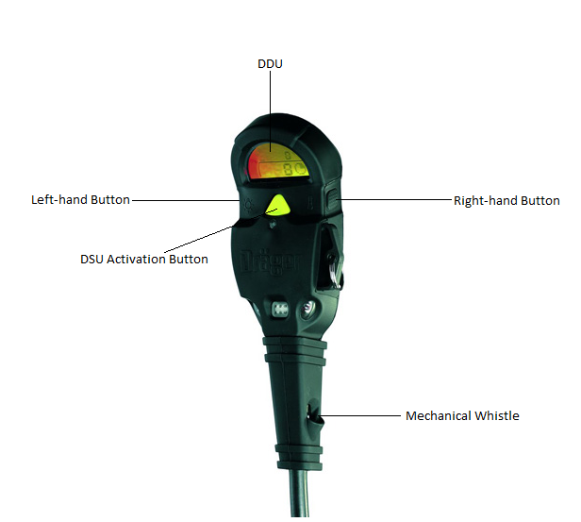

Dräger Bodyguard 7000 Key Components

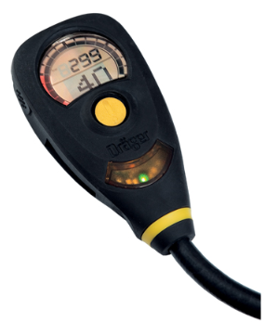
DDU
Right-hand Button
Left-hand Button
LED Cluster
DSU Activation Button

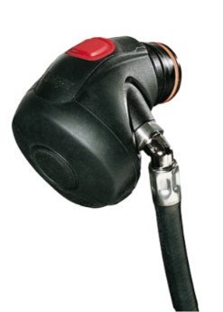
LDV Key Components:
Positive Pressure Bypass Button
Reset Button (Green or Red)
LDV Outlet Port
O-Ring (orange)
Rubber Shroud

High-Pressure Leak Test Procedure:

- Ensure Reset Button on LDV has been pressed (either green or red)
- To check the integrity of the BA set’s battery – ensure BA set’s external battery is correctly fitted, and remove the charging cable for the duration of the test.
- Fully open cylinder: activating the Bodyguard, and follow instructions on Digital Display Unit (DDU)
DDU Display | User Action Required
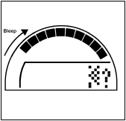 | Action required – Yes  - Depress left hand button to select the high pressure leak test.
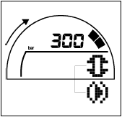 | Action required – Yes  - Fully close the BA cylinder.  - Ensure cylinder contents ≥ 280bar (or ≥ 290bar for a Monthly Test)  - Depress right hand button to confirm cylinder now fully closed, ensuring this is completed before the black squares at the top of the DDU disappear (otherwise the Bodyguard will record a fail)
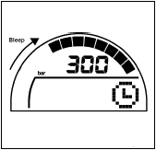 | Action required – No  - After a few seconds of stabilisation, the Bodyguard will undertake the HP Leak Test automatically.
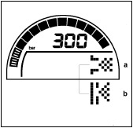 | Action required – Yes  - If the test passes: The Bodyguard will ask you to exhaust the air from the system (Fig. a):  - Cover LDV Outlet Port with palm of hand.  - Press the Positive Pressure Bypass Button  - Slowly vent the system by carefully lifting the palm of the hand from the LDV Outlet Port to maintain a slow decrease in pressure  - Observe DDU while slowly venting pressure to ensure that Low Pressure Warning Whistle on the BA set operates when the pressure reaches 55 bar (+/- 5 bar).  - If the test fails: The Bodyguard will emit 10 beeps in rapid succession, and display either a cross, or ‘Leak Test Failed’ icon (see Fig. b). Repeat test once more – defecting the set if the test fails a second time.
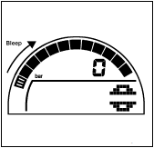 | Action required – Yes  - Ensuring you have pressed the reset button on the LDV; fully open the BA cylinder

Merlin Board Alarm Layout

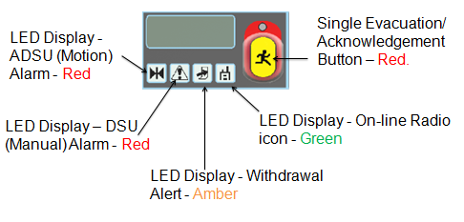

Bodyguard ADSU, DSU and Telemetry Checks:

-  WARNING – ALARM VOLUMES >100dB: USE HEARING PROTECTION WHERE REQUIRED 
- Ensure Merlin Board provided has been disconnected from charging supply
- Remove tally from Bodyguard and place into vacant slot in the Merlin Board.
- Ensure that the On-line Radio icon displays solid green.
- Allow Bodyguard to go into pre-alarm (after 21-25 seconds)
- Shake Bodyguard to cancel pre-alarm
- Allow Bodyguard to go into pre-alarm, and then full-alarm
- Ensure ADSU LED Display flashes red on Merlin Board, and that the Board alarms.
- Confirm receipt of signal on board by pressing Single Evacuation/Acknowledgement button.
- Remove tally from Merlin Board, insert into Bodyguard to cancel alarm, and then remove again.
- Depress the yellow DSU button on the Bodyguard, ensuring it alarms, and the corresponding DSU LED Display flashes red on the Merlin Board.
- Ensure Merlin Board alarms also, and acknowledge receipt of signal by pressing the Single Evacuation/Acknowledgment button on the board.
- Replace tally into Bodyguard to cancel alarm and then remove.
- Press and hold right-hand button on Bodyguard – both the Bodyguard and Merlin Board should emit a succession of 3 beeps in a row, followed by a pause. The Withdrawal Alert LED Display should also flash amber
- The DDU should display a “running person” icon, and the LED above the Single Evacuation/Acknowledgement Button should flash red
- Press the Single Evacuation/Acknowledgment button to acknowledge receipt of the signal. A confirmation beep should emit from the Bodyguard.
- Press and hold the Single Evacuation/Acknowledgement Button of the corresponding slot your tally was in. Both the Board and Bodyguard should alarm (see bullet point above)
- Depress the right-hand button on the Bodyguard to confirm receipt of the evacuation signal from the Merlin Board. This should cause the Merlin Board to emit a single long beep in response.
- Re-insert tally into Bodyguard.

SET CHECKS ON THE INCIDENT GROUND

Note: In exceptional circumstances, it may be inappropriate to complete full telemetry checks as part of the Daily Test Procedure (e.g., at time or life-critical incidents where a rapid response in BA is required, or where activation of the Merlin Board alarms at an incident may interfere with ongoing BA operations). In such circumstances, checking of the Bodyguard DSU and ADSU functions alone is permissible. These Modified ADSU/DSU Checks can be undertaken as so:

- Remove tally from Bodyguard
- Allow Bodyguard to go into pre-alarm (after 21-25 seconds), but shake it to prevent it going into full alarm.
- Allow Bodyguard to go into pre-alarm then full alarm, replacing tally to cancel this.
- Remove tally and press yellow DSU button – inserting tally again to cancel the alarm.
However, full telemetry checks must be undertaken at the earliest possible opportunity.

Face-fit Test:

- Connect LDV to facemask: ensuring positive, audible ‘click’ is heard.
- Don facemask and breathe normally. Inhale and exhale deeply at least twice.
- Test operation of supplementary flow/positive pressure device by briefly pressing black Positive Pressure Bypass Button on LDV.
- Hold breath for a few seconds to ensure no airflow from the facemask is audible.
- Check cylinder contents are at least 280 Bar (or 290 if conducting a Monthly Test).
- Fully close cylinder, then while holding breath: move head up and down and side-to-side for 8 seconds: ensure no airflow from the facemask is audible.
- Breathe down set until the air is exhausted and the mask collapses onto your face: the mask should hold onto the face with a vacuum.
- If seal is poor – readjust harness or try a different-sized mask.
- Breathe out to release vacuum whilst removing facemask. Fully slacken off head harness straps.
- Check that the gauge on the Bodyguard reads ‘0’
- Press and hold right-hand button on Bodyguard until screen goes blank: ensure BA set ‘logs-off’ Merlin Board.
- Complete BA Logbook, and enter surname and cylinder pressure (rounded down) onto tally; ensure sufficient space is left for BAECO to write “time-in.”
- Clean BA facemask appropriately and return it to its designated facemask bag.
- Ensure BA set and Merlin Board are stowed correctly, and put back on charge, and that the vehicle they are from is also on charge.

