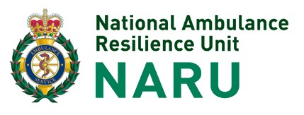 COURSE REFERENCE OPCOM Please use your course date

Operational/On Scene Command Course Pre-course Assignment
You are required to complete the attached assignment as part of this course. Please take a moment to research the questions below.

Grammar and spelling will not form part of the assessment process and you do not have to reference any sources you use in completing the assignment. We suggest you use the attached reference material to assist with the completion of the assignment.

Once completed the assignment must be returned by at least 72 hours prior to the commencement of the course.

Failure to submit this work will mean you will not be permitted to attend the course.

Completed assignments should be e-mailed to andy.bowes@wmas.nhs.uk stating “Operational Command Course – {Your Name & Date of Course} in the subject box.

- Describe the zones used in a CBRN Incident
- Identify which groups of staff from the ambulance service work in which zones and why
- What cordons are required and where are they situated?
- Which services are responsible for which cordons?
- Where would we position ourselves in relation to wind direction?
- Describe STEP 123 Plus
- Describe Initial Operational Response
- What is the default method for decontaminating a chemical that is not an irritant?
- What is the difference between CBRN and HAZmat?
- What size cordon is required for an unexploded device which is in a vehicle?
- Command is both a corporate and personal responsibility. The Manchester Arena Inquiry (MAI) has made a number of recommendations which are within the personal remit of a commander to implement. Choose two of the recommendations and discuss how you will ensure you have enhanced your knowledge and understanding.

Reference materials:
- https://naru.org.uk/resources/useful-documents/

- MAI

- Trust Major Incident plans

- Contact your trust Resilience department and or HART Team

If you have any queries in relation to any aspect of this course, please call 01980 619 567 or email
educationcentre@naru.org.uk

